QUESTION 1)

CODE:

#include <stdio.h>

int main()

{

int num,sum;

do

{

printf("Enter number: ");

scanf("%d",&num);

sum=sum+num;

}

while(num>=200 && num<=400);

{

printf("sum: %d",sum);

}

return 0;

}

OUTPUT:  
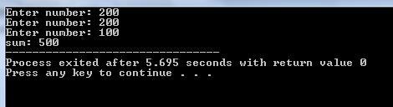

QUESTION 2)

CODE:

#include <stdio.h>

int main()

{

char ch;

int sum=0,i=1;

do

{

printf("Enter any character other than z:\n");

scanf(" %c",%ch);

sum=sum+i;

}

while(ch!='z'&&ch!='Z');

printf("Number of characters entered %d",sum);

return 0;

}

OUTPUT:

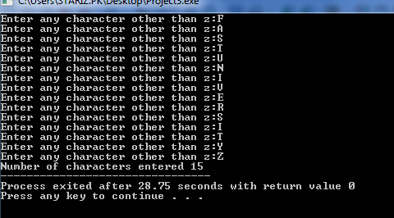  
QUESTION 3)

CODE:

include<stdio.h>

int main()

{

int n,a=100;

printf("Enter value of n:");

scanf("%d", &n);

while(a>=100 && a<=n)

{

if(a%2!=0)

printf("%d \n",a);

else;

a++;

}

}OUTPUT((wrong))

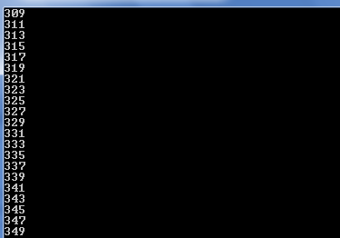  
QUESTION 5)

CODE:

#include <stdio.h>

int main()

{

int a,b;

printf("enter number1: ");

scanf("%d",&a);

printf("enter number2: ");

scanf("%d",&b);

while(a<b)

{

if(a%5==0)

printf("%d\n",a);

a=a+1;

}

return 0;

}

OUTPUT:

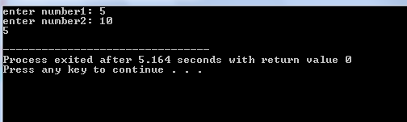

QUESTION 6)   
CODE:  
#include <stdio.h>

int main()

{ // TASK 6

int i, j;

for (i = 1; i <= 5; i++)

{

for (j = 1; j <= i; j++)

{

printf("%d ", i);

}

printf("\n");

}

return 0;

}

OUTPUT:

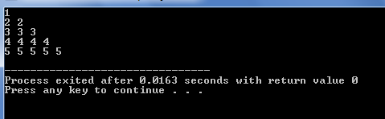

QUESTION 7)

CODE:

#include<stdio.h>

int main()

{

float b, e, a;

printf("Enter a base: ");

scanf("%f",&b);

printf("Enter an exponent: ");

scanf("%f",&e);

a = pow(b,e);

printf("Answer = %f",a);

}

OUTPUT:

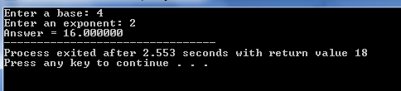

QUESTION 8)

CODE:

#include<stdio.h>

int main()

{

int i;

for(i =100; ;i--)

{

printf("var: %d\n",i);

if (i==88)

break;

}

printf("Out of for- loop");

return 0;

}

OUTPUT:

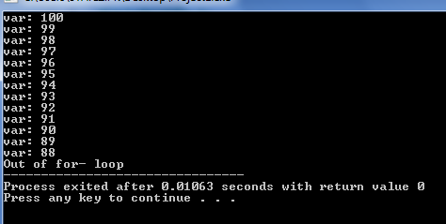

QUESTION 9)

CODE:

#include<stdio.h>

int main()

{ // TASK 9

int i, j, a;

char ch;

for (i =1;i<=5;i++)

{

for (j =1;j<=i;j++)

{

printf("%d",j);

}

for (j=4;j>=i;j--)

{

printf("\*");

}

printf("\n");

}

return 0;

}

